How to Use Box.com

Cloud Concierge Support Team
Table of Contents

Introduction 3
Obtaining a README URL from the Provisioning website 3
Obtaining a README URL from a Confirmation Email 4
Creating Your Own Box.com Account 4
Logging into Box.com 6
Editing Your Profile 8
Navigating from the MASTER README Folder 9
Version Control 12
Using Box.com Comments for Collaboration 14

Introduction
Box.com is a useful website that provides simple file collaboration. By incorporating Box.com and Cloud Concierge, users can access important files regarding instances that they create or conduct sales demonstrations with. This document will guide you through the most relevant functionality features that you will utilize on Box.com. There are additional Box.com features that are not mentioned in this document but you do not need to worry about those while using Box.com in conjunction with Cloud Concierge.
If you need further assistance regarding any Box.com related issues, please contact Box Support.

Obtaining a README URL from the Provisioning website
All images listed on the ‘Provisioning’ page in Cloud Concierge contain a README URL within the image description. While logged into the Cloud Concierge website, please copy and paste the URL that is listed in the description of an image. This can be found by clicking on the ‘ >’ sign next to an image (as shown below). After locating the URL that is listed in the image description, copy the URL into a browser window and press ENTER to view the README file and all other related documents that are listed in the image folder on Box.com. An example of this process is as follows:
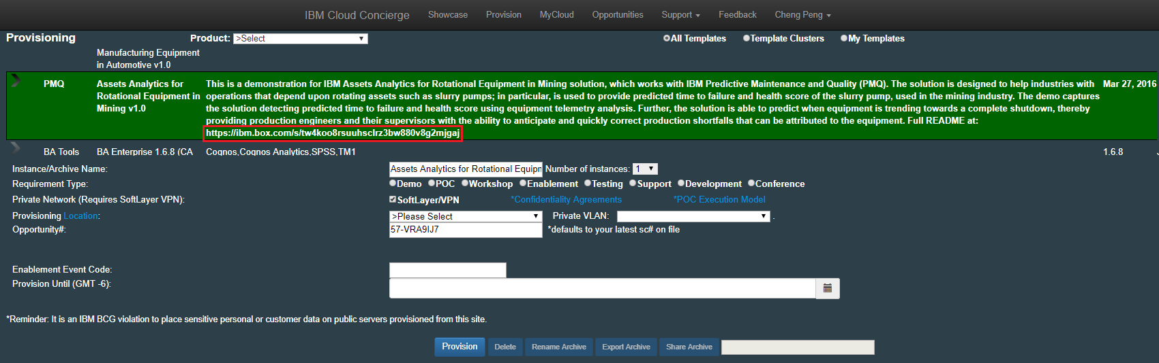
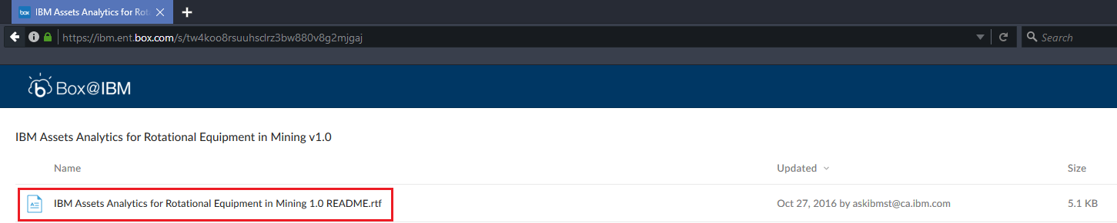

If you encounter an image that is currently missing a README URL in the Provisioning description, please contact ASKIBM at askibmst@ca.ibm.com immediately so this issue can be resolved.

Obtaining a README URL from a Confirmation Email
A user receives a confirmation email for all images provisioned on the Cloud Concierge website. A README URL can be found within all confirmation emails. An example of this is as follows:
This is an automated notification based on a SoftLayer provisioning process that has been completed. This email contains important information regarding your provisioned system as well as detailed information for Cloud Concierge Support. See the bottom of this email for Support information.
Primary IP Address: 169.60.17.217
Private IP Address: 10.93.28.131
Expiration Date: Sep 28, 2017 11:00:00 AM after which the instance will get deleted.
Computer Name: cheng97120107.poc.demoibm.com
Name in My Cloud: BA Enterprise Platform V1.5.1 Redux
Datacenter: dal10
Instance ID: 38877983
Note: Be sure to back up your work. We cannot recover lost data.
Please carefully review the description of the template:
SPSS 17.1, Cafe FP4. TM1 10.2.2 FP3, Cognos BI 10.2.2 FP2. SPSS Modeler Gold (CDS7/ADM). Application logins are administrator, pm, vision for BI/TM1, and admin for CDS/ADM. Passwords are all IBMDem0s. Remote Desktop Port is 3333, connect via [ipaddress]:3333. README: https://ibm.box.com/s/s0y5dan5j5zrxk9wch2kkp0lzl46gnwk
The user can simply copy and paste the URL that is listed within the confirmation email into a browser window. At that point the user will be taken to the image folder which contains the README file for this image as well all other documents that are within the image folder.

Creating Your Own Box.com Account
Great news! If you are an employee of IBM, you already have a Box.com account waiting for you. All you need to do is visit https://ibm.app.Box.com/login and use your W3 login credentials to log in.
If don’t remember your login credentials, please click ‘Reset Password’. After entering your email address, a system generated password will be sent to you. You must change this password upon your next login. This process will look as follows:
Step 1: Go to the login screen for Box.com here https://account.box.com/login
Step 2: Click ‘Reset Password’
Step 3: Enter your email address
Step 4: Click ‘Reset Password’
Step 5: You will see the screen below after clicking ‘Reset Password’
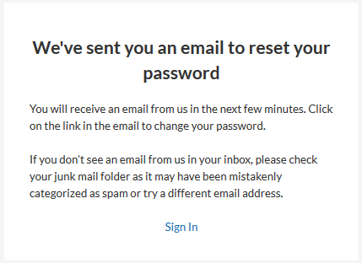
Step 6: Go to your inbox, select the email and click the ‘Reset Password’ button
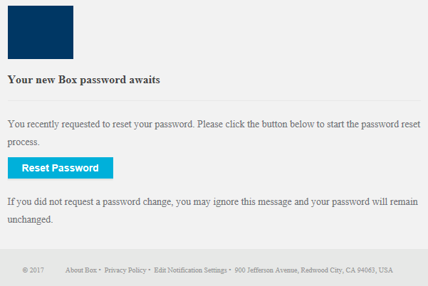
Step 7: Enter a new password and re-enter it to confirm
Note: You will receive an error message if you do not input a new password that meets the requirements.
Step 8: You are now logged into your Box account using your updated login credentials
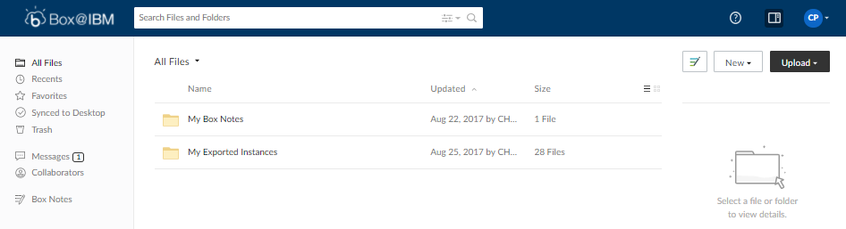

Logging into Box.com
Note: To log into your Box.com account, please follow the instructions listed below:
Step 1: Visit https://ibm.app.Box.com/login and click ‘Continue’.
Step 2: Enter your username and password
Step 3: Click the ‘Sign In’ button.
Step 4: Due to a Security mechanism on Box.com, you may be taken to the following screen: 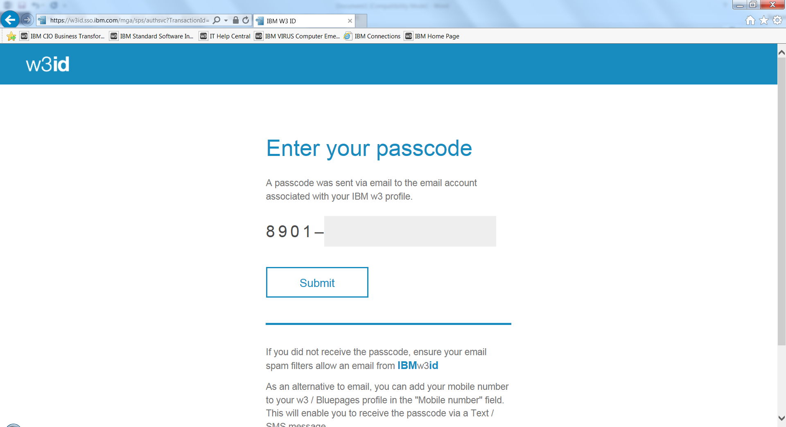
Step 5: A system generated email will be sent to you. Please input the second half of the passcode that is sent to your email address in order to successfully sign in. 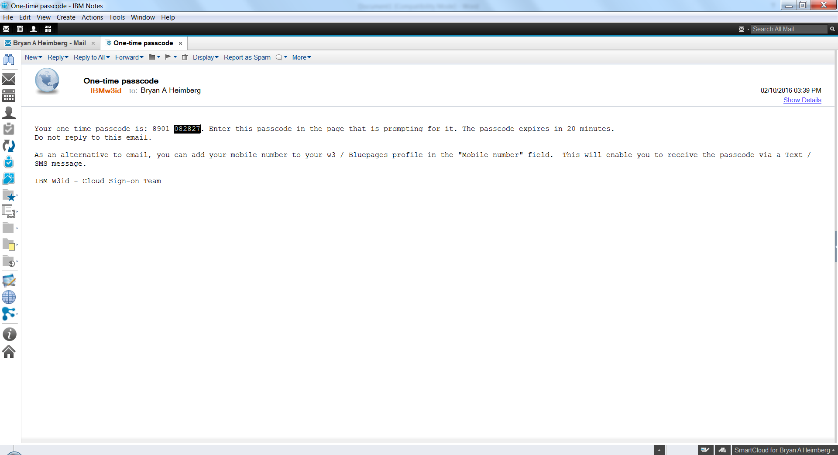
Step 6: After entering the second half of the passcode into the login area, you will be signed into Box.com.
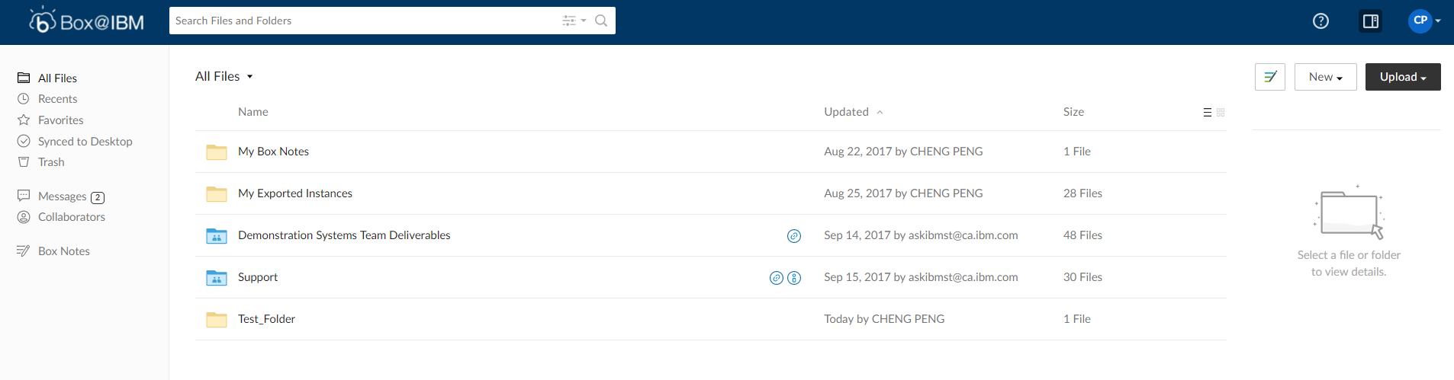

Editing Your Profile
Note: After signing into your Box.com account for the first time, you should configure your account settings. Doing so will provide the best experience possible to you while using Box.com. To set up your Box.com account, please take the following steps:
Step 1: After logging into Box.com, click the drop-down arrow beside the icon with your initials on the top right corner of the Box.com window and select ‘View Profile’
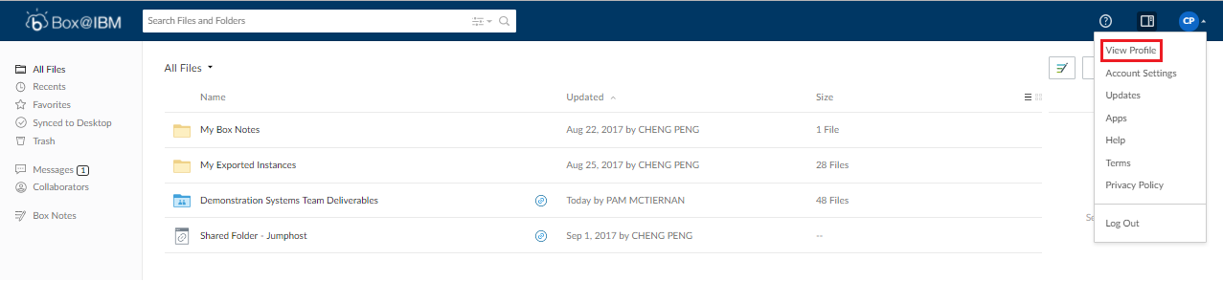

Step 2: Enter any relevant information that you would like to include by clicking ‘Edit Information’ and then entering relevant information.

Step 3: Make sure to press the ‘Save Changes’ button in order to save and update your Box account with your information.
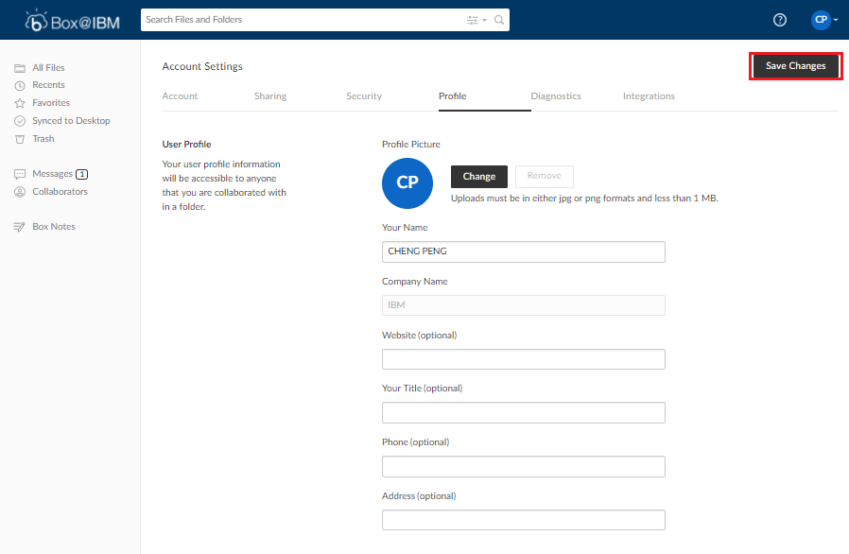

Navigating from the MASTER README Folder
Note: As a standard user, you can also access all README Documentations by going to the ‘Support Page’ in Cloud Concierge.
All images are sorted by Focal, so please be sure to know which Focal the image pertains to. This can be found directly on the Cloud Concierge website as follows: 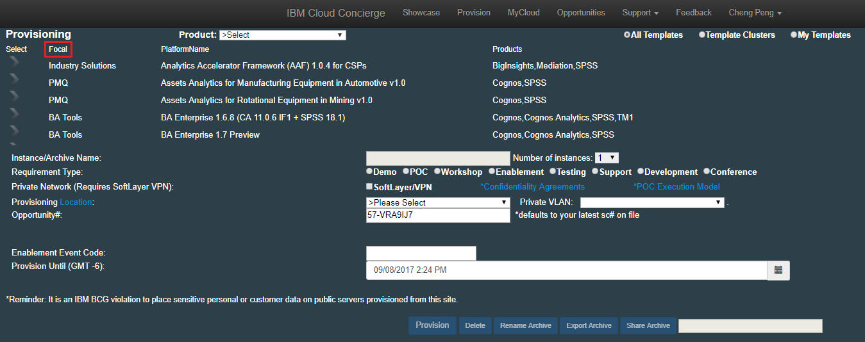
After selecting the Focal that your image belongs to, select the image that you are trying to find information about. At this point, all files that pertain to that specific image will be listed. Most of the time, the README file of an image is the most important and most relevant file listed in an image folder. However, some files have additional supporting documents that may be useful to you as well. This varies per image.
As an example, we will be performing a walkthrough to find the README file associated with the image BA Enterprise 1.6.8 (CA 11.0.6 IF1 + SPSS 18.1) which belongs to the BA Focal.
Step 1: Access all README Documentations in the Box.com on the ‘Support Page’
Step 2: Select the BA folder, then click the README file inside the BA Enterprise Platform V1.6.8 folder

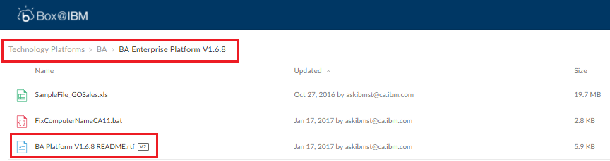
Step3: Locate the README file in this list. As you can see above, the README file is the third file listed in this folder. As a general tip, many times you can find the README file in a long list of files within a folder by searching for the light blue ‘V’ next a file. This pertains to version control, which will be discussed later in this document.

Uploading Your Own Documents into a Folder
Note: To upload files into your Box folder, please take the following steps:
Step 1: Log into your Box.com account and click ‘Go to your files’ near the top right hand corner to access your personal files.
Step 2: Click the ‘New’ drop down button and select ‘Folder’ to create a new folder
Note: Users can choose specific permissions and share their files with other users if desired.
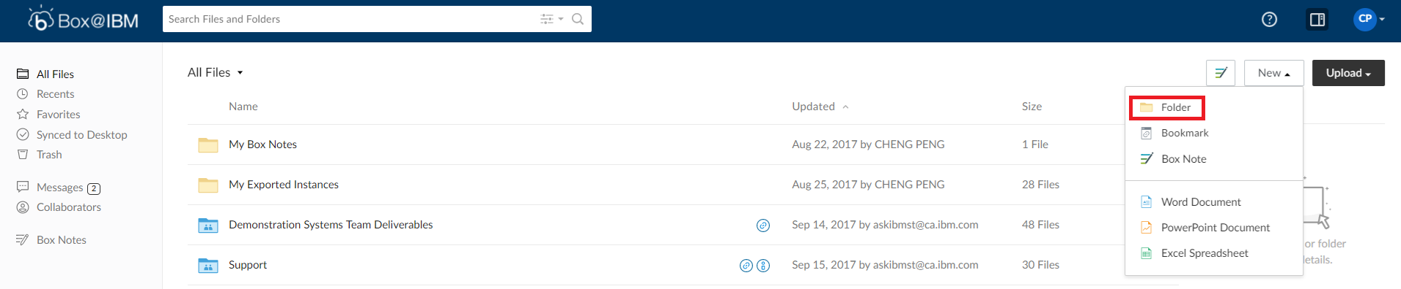
Step 3: Now, click on the newly created folder and then select the button ‘Upload’
Note: Users have the option of choosing to upload a file or folder
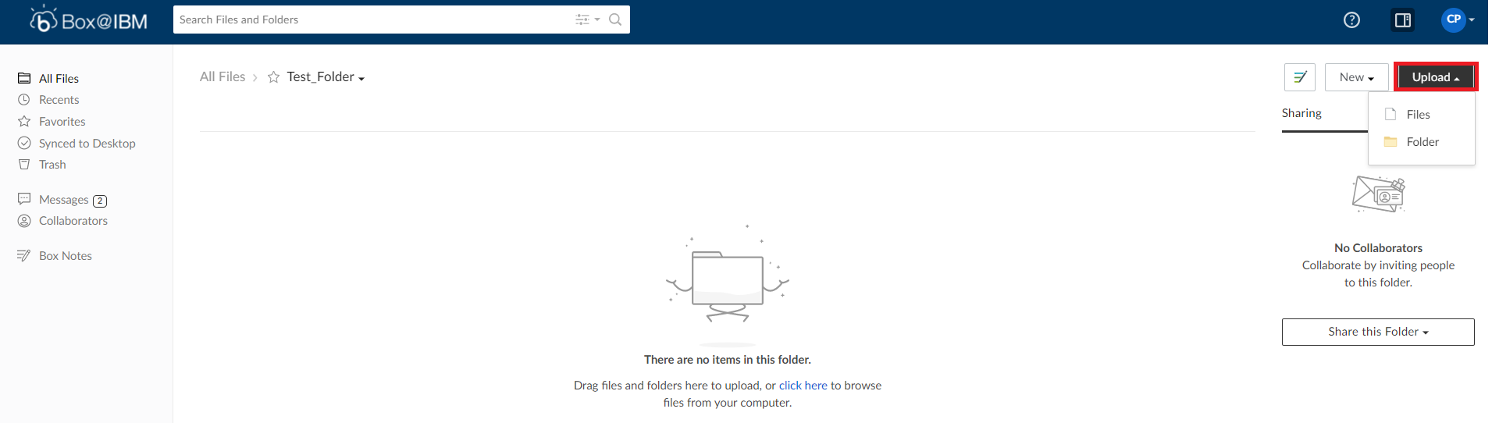
Step 4: Browse for the desired file(s) and click ‘Open’
Note: You can check your privileges by clicking your initials on the top right hand corner and select ‘Account Settings’.

Version Control
Version Control is an important feature on Box.com as it allows a user to revert to older versions of a document if desired. For example, if a document has been updated, it needs to be placed onto Box.com. Instead of replacing the old version with a brand-new document, users can simply upload the new document as the most recent version if the name matches.
Please follow these instructions when using Version Control:
Step 1: Right click on the desired file and select ‘Upload New Version’ 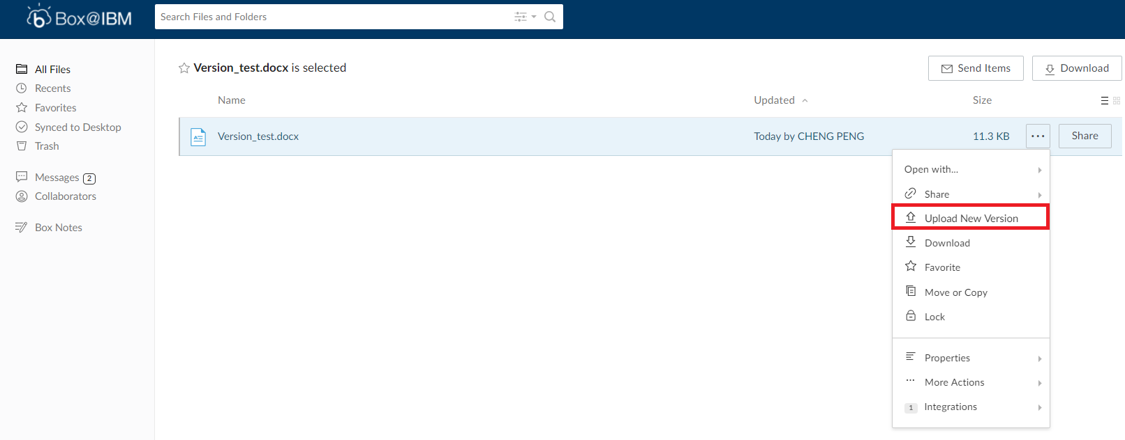

Step 2: Browse for the new version and click ‘Open’
Note: Ensure that the file name is identical between the new and older version 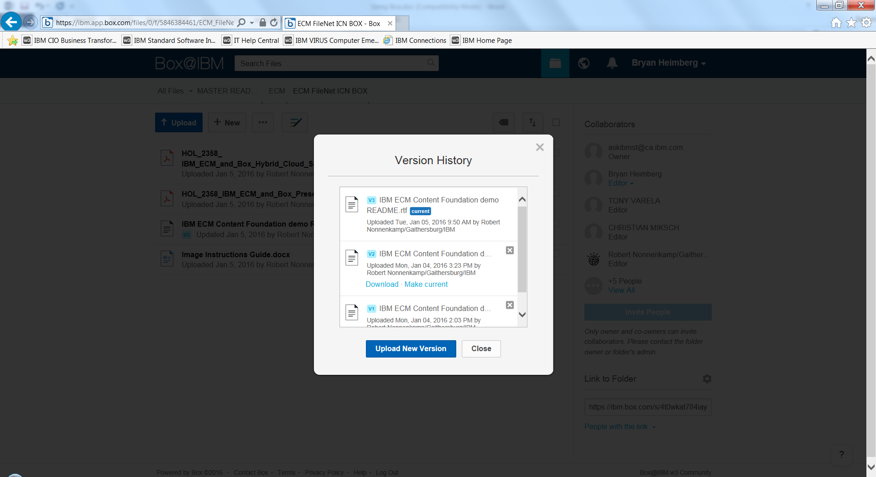
Step 3: The new version of the document should now be displayed along with a small icon indicating that this is version 2.
Note: To access the Version History, click the small icon indicating the version number.
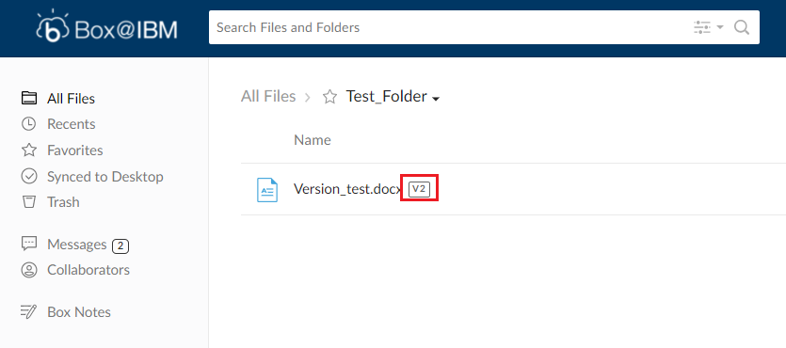

Step 4: Click ‘Download’ to download a different version of the document that is currently selected or click ‘Make Current’ to select a different version of a document to display as the primary version that displays when a user opens the document.
Note: All versions of the document and associated information such as author name, upload date, and upload time are now displayed.
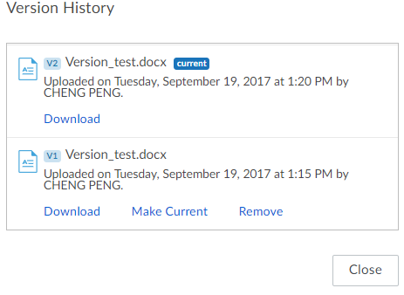

Using Box.com Comments for Collaboration
Collaboration on Box.com is highly encouraged and is strongly recommended. If you encounter any issues regarding a specific file on Box, please use comments to raise alert of the issue. All users that belong to a folder will receive a notification via email regarding new comments made. Comments have many beneficial use cases such as adding suggestions to various sections of a file.
Comments on Box.com are made at the file level and are very easy to create. To make a comment, please take the following actions:
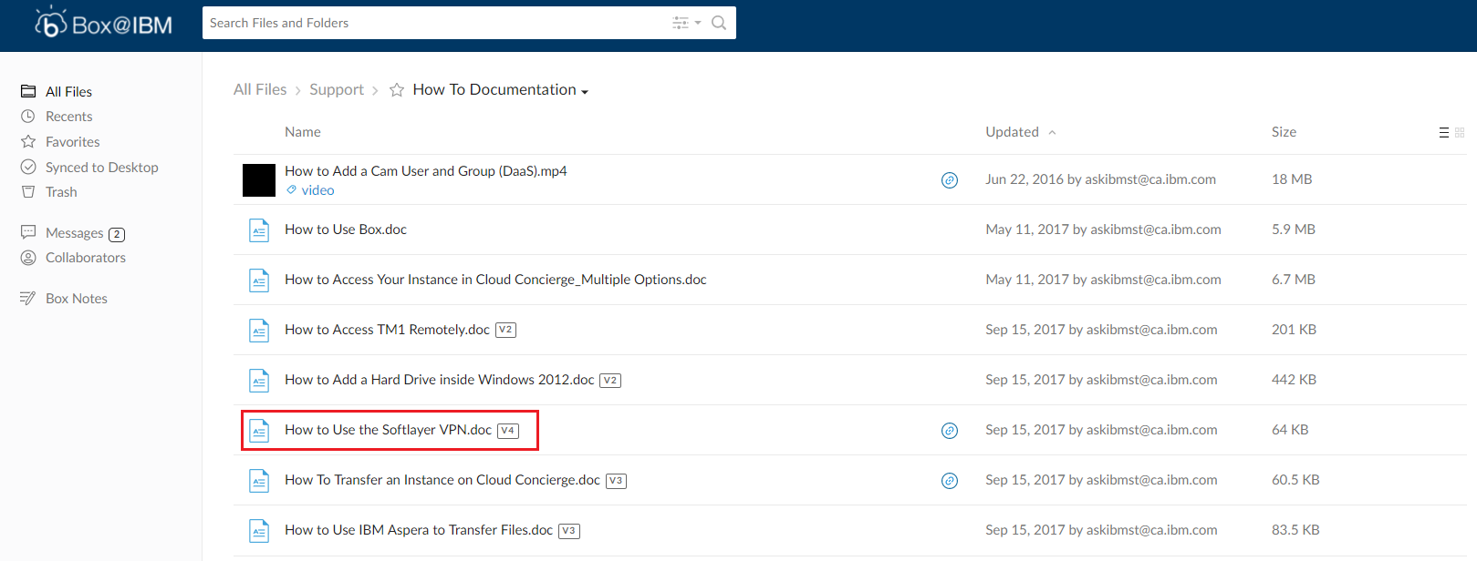
Step 1: Click on the name of the file you wish to add a comment.

Step 2: In the preview screen, enter your comment in the text box located on your right.
Note: To notify a specific user, please use the @mention feature
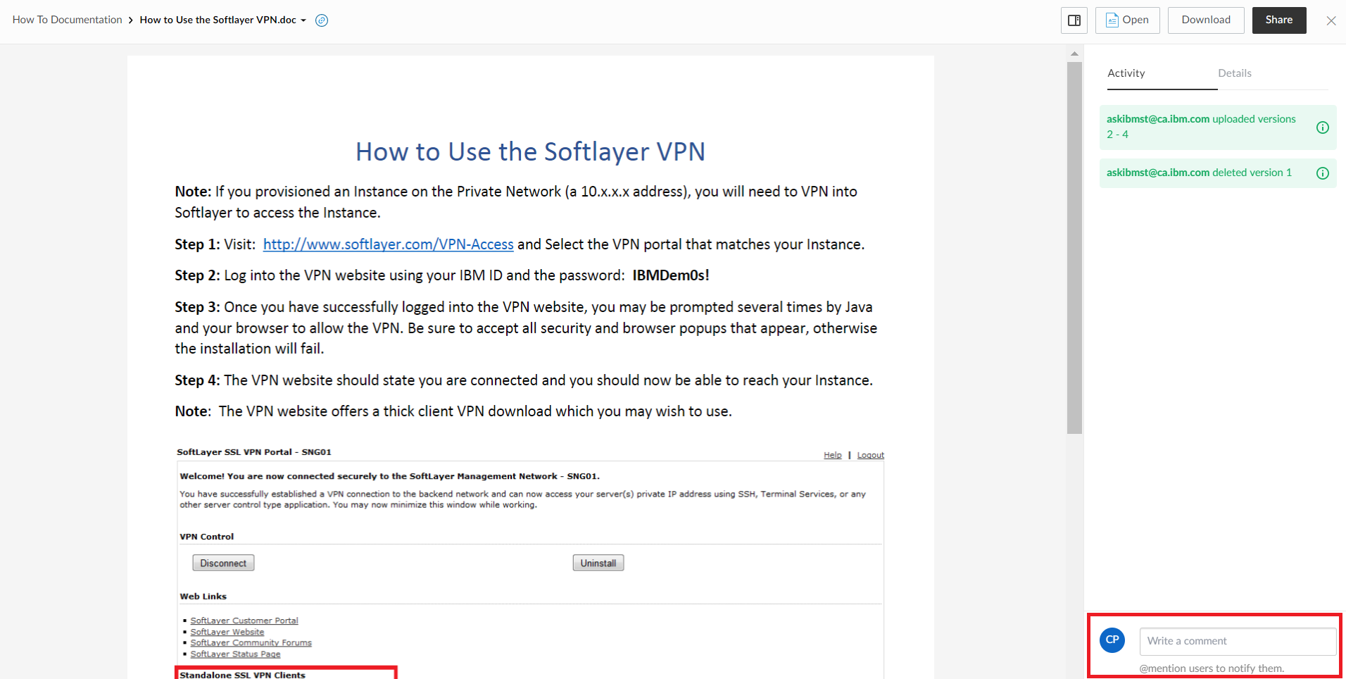
Step 3: After inputting text, press ‘Post’ to enter the comment. All users that belong to the ‘How to Documentation’ folder will now be notified that this comment has been posted.
Step 4: If you change your mind and decide not to post a comment, simply click ‘Cancel’ to exit the Comment area.

